**RIF-KATUNDA: DISEASE KNOWLEDGE CENTER**

**Introduction**

Passionfruit plants in Uganda are affected by a range of fungal and viral diseases, which potentially cause high plant and yield losses. Accurate disease diagnosis of passionfruit diseases is essential for effective control. Disease identification is difficult, particularly for farmers that are new to the industry. This document provides information on the most common passion fruit diseases in Uganda.

**Diseases**

**Woodiness**

This is a viral disease. Woodiness virus belongs to the group of viruses called potty viruses from viral family of *potyviridae*.

The viruses are spread by aphids (green flies), where they feed on an infected leaf before they can spread the viruses to healthy plants. Aphids are not often seen on passionfruit. They land to feed, and then move through the crop. Pruning tools can also spread the viruses. The viruses are not spread through seeds.

The disease affects the plant at all stages from nursery to mature plants.

**Disease Cycle**

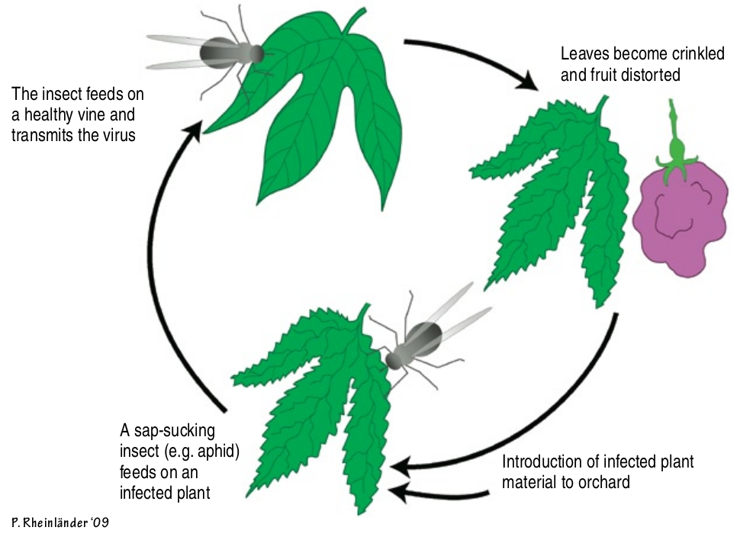

Figure 1: Woodiness Disease Cycle

**Symptoms**

* The disease is visible on leaves as a light or dark green mosaic pattern often with light yellow discoloration.
* Affected fruits become very hard like a stone and are usually deformed, shapeless, and undersized. Sometimes the disease makes the affected fruit crack.
* Exhibition of yellowish distorted plant parts such as shapeless, small-sized, and clucked leaves.
* The entire affected plant or branches can be stunted.

**Control**

Chemically, this disease cannot be controlled using fungal chemicals to spray the affected plants. However other ways can be practiced and these include;

* ensure you get seedlings that are certified to avoid this disease.
* Plant hygiene measures should be practiced, especially during training and pruning. Pruning knives should be sterilized by use of appropriate disinfectant, both before and after use.
* Passion fruits should never be planted again in the same field or in the immediate vicinity particularly where a severe attack has occurred.
* Control Mealy bugs, aphids, scales and white flies that may be vectors

**Brown spot**

This is a fungal disease caused by *Alternaria passiflora*. The disease affects the passionfruit leaves, stems, and fruit, it is triggered by a humid microclimate around the plant.

The produce of fungal seeds in large numbers on diseased plant parts lead to brown spot fungus spread. These spores are carried by wind or rain on to healthy leaves, laterals and fruit where they germinate and cause infections as well as the unpruned plants that grow under shades, fields that are established in the swamplands, and congestion in the nursery are very serious subject to brown spot attack.

Disease Cycle

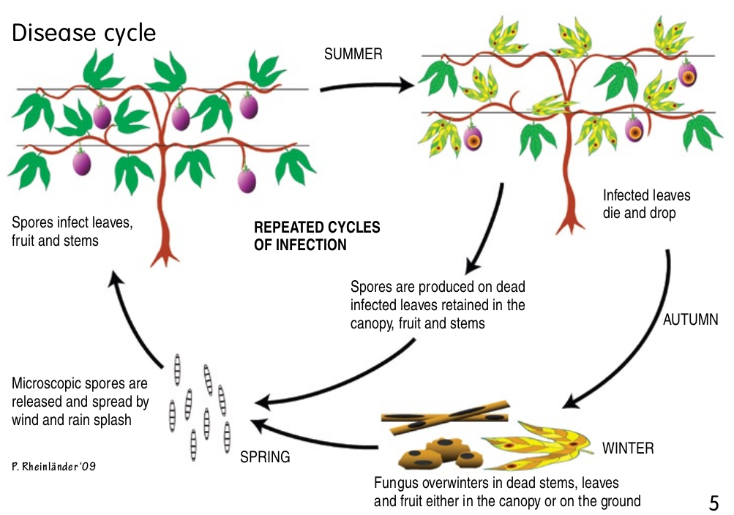

Figure 2: Brown spot Disease Cycle

**Symptoms**

* Circular dark-brown spots develop which later enlarge and from lighter colored central areas appear on leaves.
* The fungus also attacks the fruits which develop brown sunken spots more or less circular in outline.
* Laterals develop dark brown marks which may reach several inches in length. The marks often encircle the laterals and cut off the sap flow with resulting death of all parts beyond.

**Control**

* *Pruning*

This is the removal of unwanted branches from a plant.   
Pruning the vines is necessary to prevent the growth becoming too dense on the trellis, pruned vines dry out more readily after rain and also allow better penetration and movement of air that significantly assist in control

* *Spraying*

After pruning, the plants are sprayed with fungicides such as Antracol. Routine sprays should also be applied at monthly intervals during spring and early summer, and at two-monthly intervals thereafter.

**Collar Rot Disease**

This is a soil-borne fungal disease caused by the fungus, *Fusarium* *solani*. The rotting of the plant starts at the collar hence the name collar rot. The disease is most common in wet and cold seasons.

**Symptoms**

* Appearance of cracks on passionfruit stems just above soil level after 10 months. The cracks become larger and the diameter of the stem increases. When the stem is cut open, grubs with black heads are seen inside short tunnels.
* Purplish spots on the stem are early signs of the disease, as the rot progresses, the lower part of the trunk becomes girdled, resulting in leaf and stem wilting.
* Later, rots start from the tunnels, and destroy the collar region. The rots cause the stems to break, but even if that does not happen, the rots cause the leaves to turn pale green and fall, the branches to die back and, eventually, the death of the plant.

**Control**

* Reducing water accumulation around the roots by planting in raised beds can decrease infection.
* Ensure properly drained soils and Avoid planting in areas previously infected
* On seeing any symptoms, a farmer should scrape off the infection from the bark using a knife.